COURSE NAME: Theory of Computation COURSE CODE: CSA13

COURSE OUTCOME COVERED

CO3: Construct regular expressions, and use the pumping lemma and closure properties to analyze regular languages. (BL:3)

Assessment Tool Weightage: 40%

QUESTIONS: 5 Total Marks:50
Duration : 1 Hour

Experiments

Code of Conduct:

I E.Gopi Krishna-192311347 (Name / Reg No) certify that this submission is my original work and that I have adhered to the guidelines specified for this assessment.
I understand that any violation of academic integrity rules will result in disciplinary action.

Signature of the student:

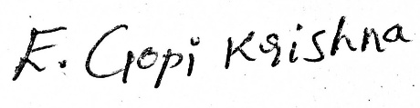

1 | Write a C program to check whether a given string belongs to the language defined by a Context Free Grammar (CFG)  S → 0A1 A → 0A | 1A | ε
2 | Write a C program to check whether a given string belongs to the language defined by a Context Free Grammar (CFG)  S → 0S0 | 1S1 | 0 | 1 | ε
3 | Write a C program to check whether a given string belongs to the language defined by a Context Free Grammar (CFG)  S → 0S0 | A A → 1A | ε
4 | Write a C program to check whether a given string belongs to the language defined by a Context Free Grammar (CFG)  S → 0S1 | ε
5 | Write a C program to check whether a given string belongs to the language defined by a Context Free Grammar (CFG)  S → A101A A → 0A | 1A | ε

Programs:
Experiment 1

Aim
To write and implement a C program to check whether a given string belongs to the language defined by the Context-Free Grammar (CFG):
S → 0A1
A → 0A | 1A | ε
Code:
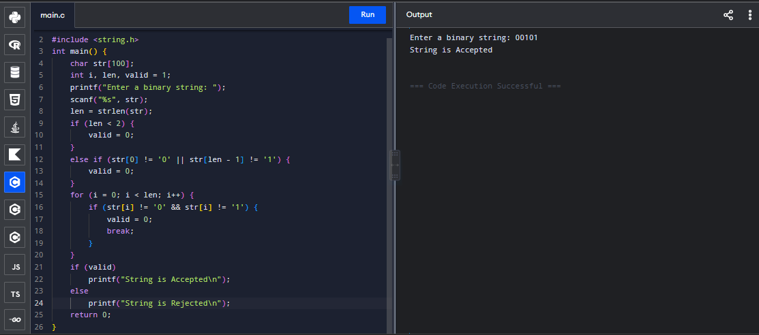

Conclusion
The C program was successfully implemented to validate strings generated by the given CFG. The program checks whether the input string starts with 0, ends with 1, and contains valid binary symbols. The given string was successfully classified as Accepted or Rejected.

Experiment 2

Aim
To write and implement a C program to check whether a given string belongs to the language defined by the Context-Free Grammar (CFG):
S → 0S0 | 1S1 | 0 | 1 | ε
Code:
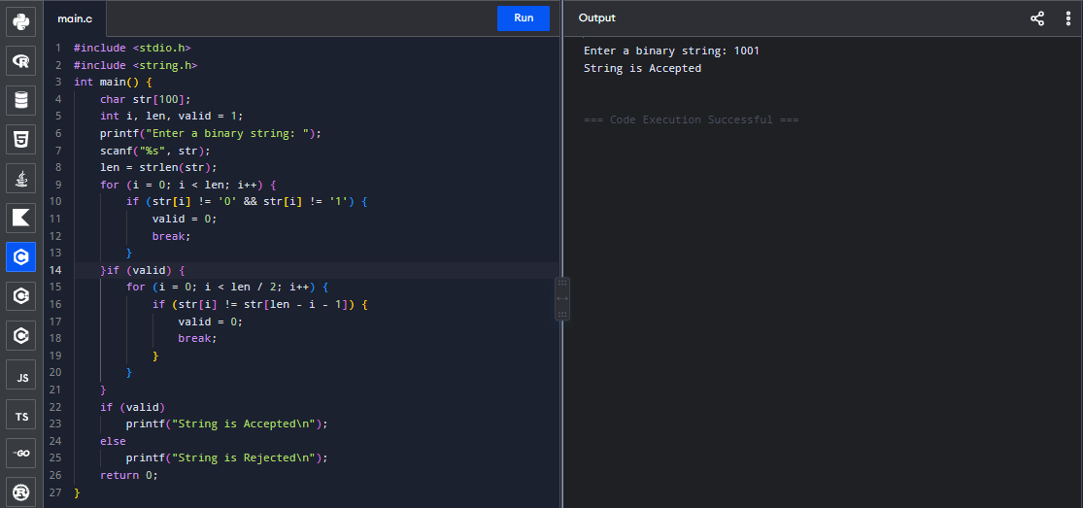

Conclusion
The C program was successfully implemented to verify whether the given binary string is a palindrome according to the specified CFG. The program compares the characters from both ends and determines whether the input string is Accepted or Rejected.

Experiment 3

Aim
To write and implement a C program to check whether a given string belongs to the language defined by the Context-Free Grammar (CFG):
S → 0S0 | A
A → 1A | ε
Code:
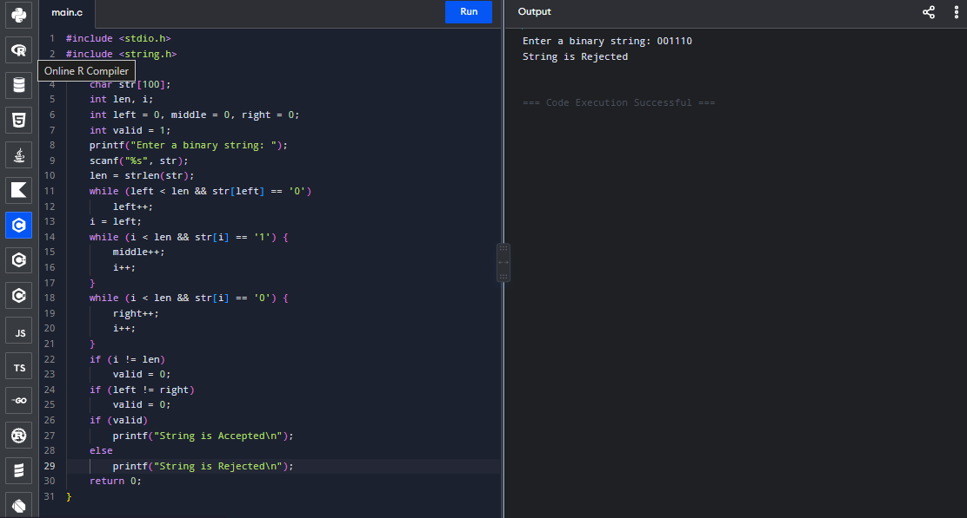

Conclusion
The C program was successfully implemented to validate strings belonging to the language generated by the given CFG. The program checks whether the input follows the required structure of equal numbers of 0s at both ends with any number of 1s in between, and displays Accepted or Rejected.

Experiment 4

Aim
To write and implement a C program to check whether a given string belongs to the language defined by the Context-Free Grammar (CFG):
S → 0S1 | ε
Code:
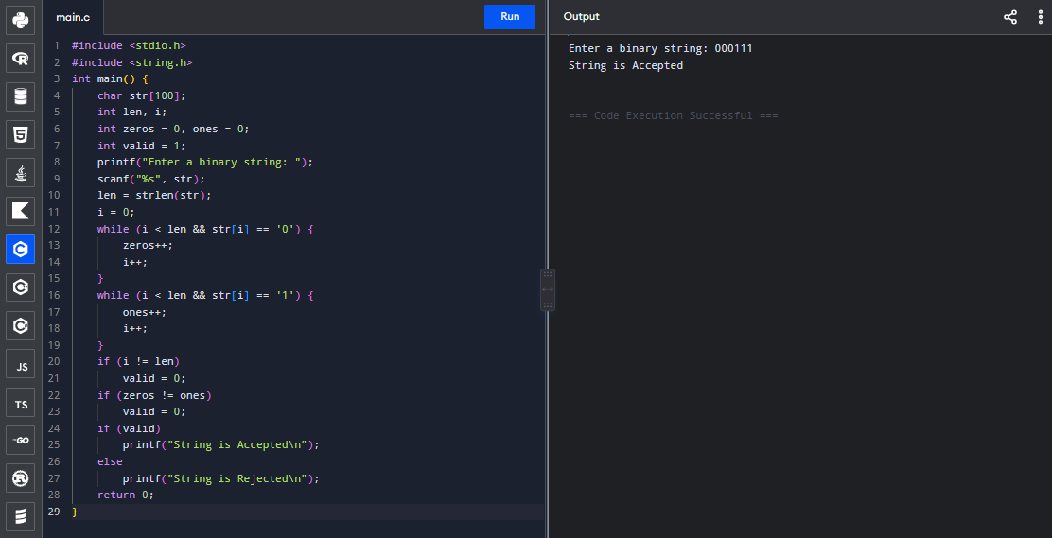

Conclusion
The C program was successfully implemented to verify strings belonging to the language 0ⁿ1ⁿ. The program checks whether all 0s occur before the 1s and whether the number of 0s is equal to the number of 1s. The input is then classified as Accepted or Rejected.

Experiment 5

Aim
To write and implement a C program to check whether a given string belongs to the language defined by the Context-Free Grammar (CFG):
S → A101A
A → 0A | 1A | ε
Code:
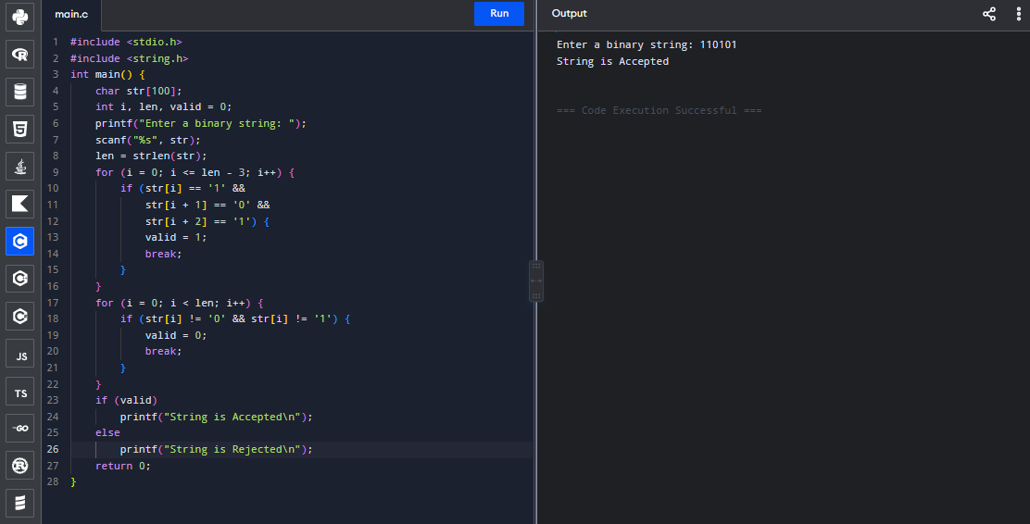

Conclusion
The C program was successfully implemented to validate strings generated by the given CFG. Since A can generate any binary string, the program checks whether the input contains 101 as a substring. The input string is successfully classified as Accepted or Rejected based on the given grammar.

RUBRICS FOR CALCULATION

Criteria | Weightage | Level 4 – Exemplary (5 Marks) | Level 3 – Proficient (4 Marks) | Level 2 – Developing (2–3 Marks) | Level 1 – Beginning (0–1 Mark)
Conceptual Understanding | 30 | Demonstrates clear and complete understanding of the concept | Good understanding with minor gaps | Basic understanding with some misconceptions | Poor or incorrect understanding
Accuracy of Answer | 25 | Completely correct answer with no errors | Mostly correct with minor errors | Partially correct with noticeable errors | Incorrect or irrelevant answer
Application of Knowledge | 20 | Correctly applies concepts to solve the question/problem | Applies concepts with minor mistakes | Limited or partially correct application | No or incorrect application
Completeness of Response | 15 | Covers all required parts of the question | Covers most parts with minor omissions | Covers only some parts | Incomplete or missing response
Clarity & Presentation | 10 | Clear, concise, and well-organized answer | Understandable with minor issues | Somewhat unclear or poorly structured | Difficult to understand

